University of Central Punjab
Faculty of Information Technology

PF Project

Project:

Game: Rat in a Maze

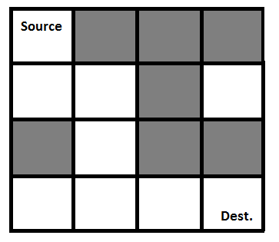

You have to make a game in which rat will find the path from source to reach destination position.

A Maze is given as N*N matrix of blocks where source block is the upper left most block i.e., maze[0][0] and destination block is lower rightmost block i.e., maze[N-1][N-1]. A rat starts from source and has to reach the destination. The rat can move in multiple direction. Possible directions can be Right, Left, Up and down.

In the maze matrix, 0 means the block is a dead end and 1 means the block can be used in the path from source to destination. You have to use other number like -2 to decrease the lives of rat.

Major Functionalities:

1) Start New Game
User will start new Game by entering his/her name and their scores must be maintained.
2) Pause/Resume Game
It will save the state of game. It will then started from where the user left the game.
3) Levels (Easy, Medium, Hard)
On user’s selection of level, you will select the maze of that complexity. You will make multiple files for multiple levels and you have to load these levels on user’s selection.
4) Show Highest Score Table
Show Scores of each player. You have to store the score in ascending order in file name as “scores.txt”
5) Exit
Exit the game by storing the score of user.

Functionalities Required:

1) Load Maze:
You have to load maze from file on user’s level selection. You will keep the original maze without showing it. As, user will find the way, you will show that path in that similar way.
You have to show the proper maze as shown above diagram based upon the 0,
1 and -2.
0 will represents the way is blocked. 1 will represents the way is open. And you can show any monster image on -2, while creating maze.
2) Check Move:
You have to check whether the specific move is possible or not. Like if you stand on first box, then you can’t able to move up, right (Backward).
3) Is Safe:
a. Check whether the specific move is safe or blockage. If blocked, then you can’t
able to move in that direction. You have to find another way for it.
b. And if user will hit -2 in box, then you have to reduce the life of rat. Max lives can be 3.
4) Update Score:
a. Increase Score:
i. Score will be increased by 5, if user will find the box successfully. b. Decrease Score:
i. If user will find -2 block then it will be reduced by 5 and also one life will be decreased.
ii. If user will find block of (0), then it will be reduced by -1.
5) Show Full path :
You have to show the full path from where the user pass away.
6) Save user Score
You have to save the user’s scores against his/her name.
7) Show High Score:
You have to show the High Score table and their respective names.

Topics which will be used in this Project:

• Functions
• Filling
• Pointers
• 2D Arrays
• Dynamic Memory
• Structures

